**Data Warehouse and**

**Business Intelligence**

INFO 7290

(SECTION-1)

Assignment-04(Part-1)

NAME: Ayush Mangal

NUID: 001873174

**Solution 1:**

Following steps have been done for this solution:

1. Files have been renamed to 2013,2014,2015,2016 respectively.
2. Files have been edited to remove the extra items at the top of the tab but the data is formatted as is.
3. Files have been modified from xls to tab delimited.

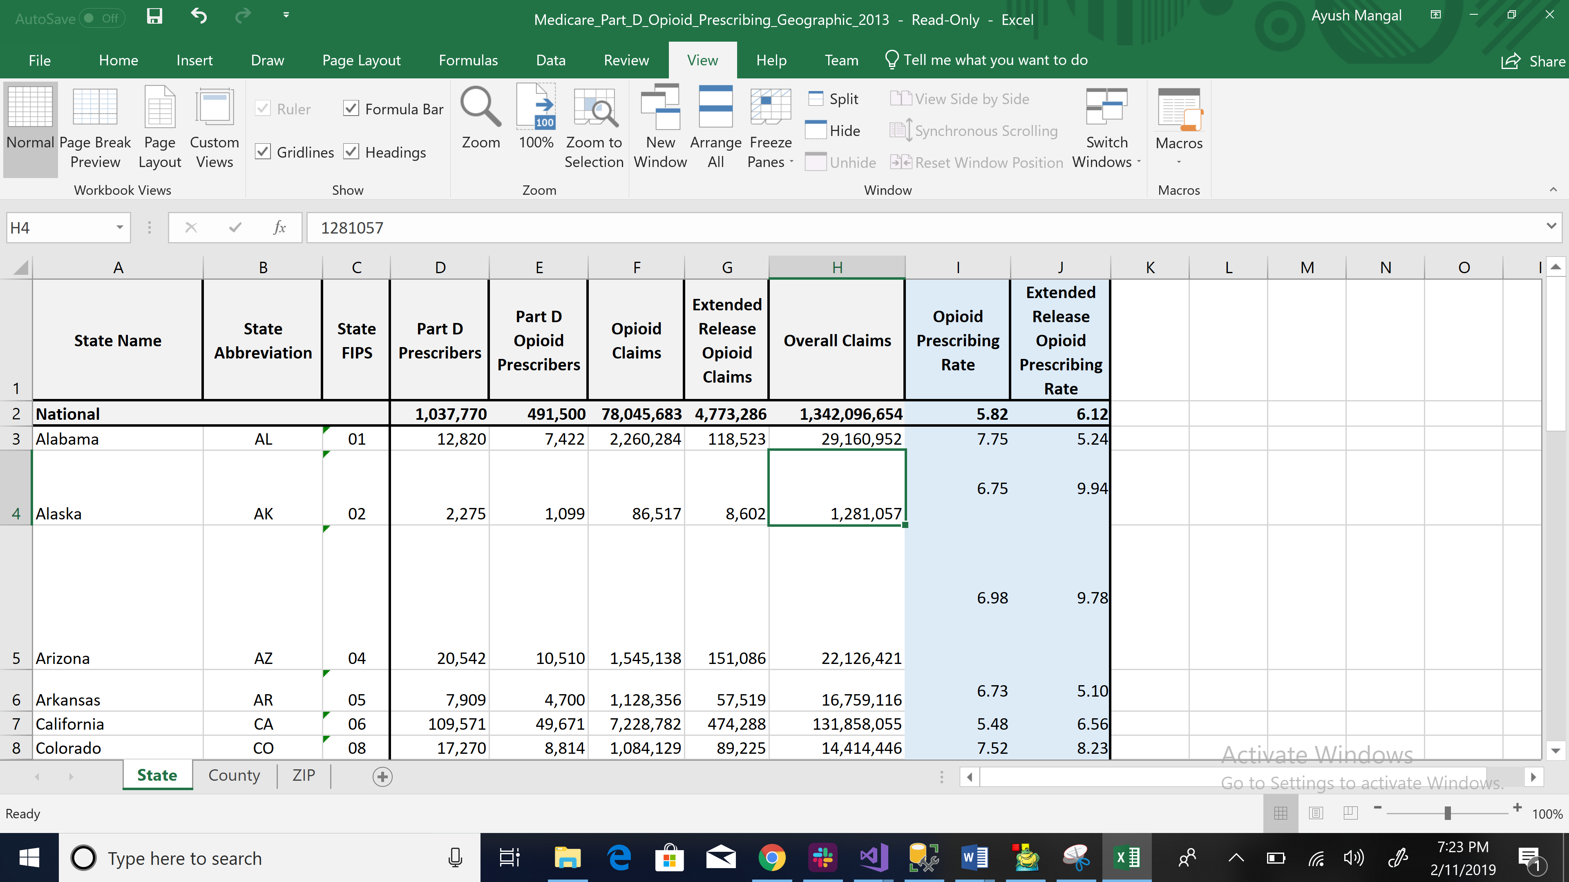  
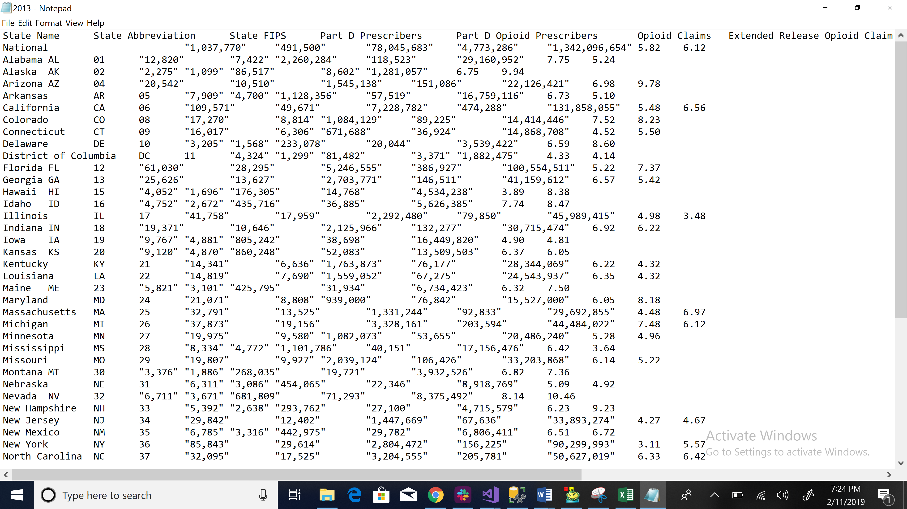

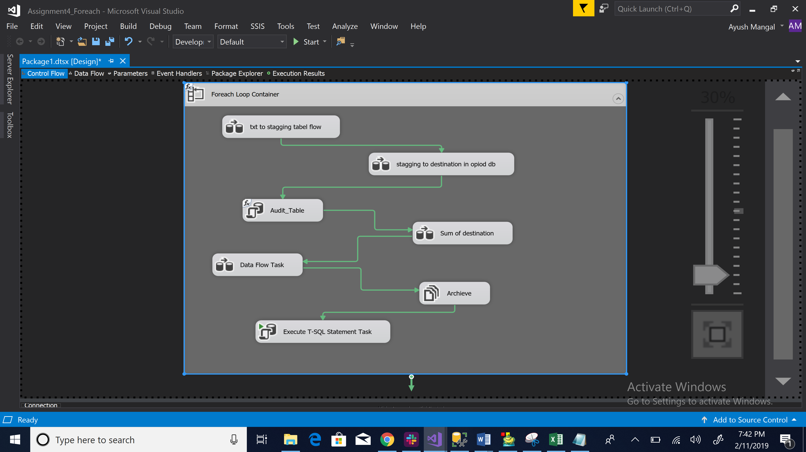

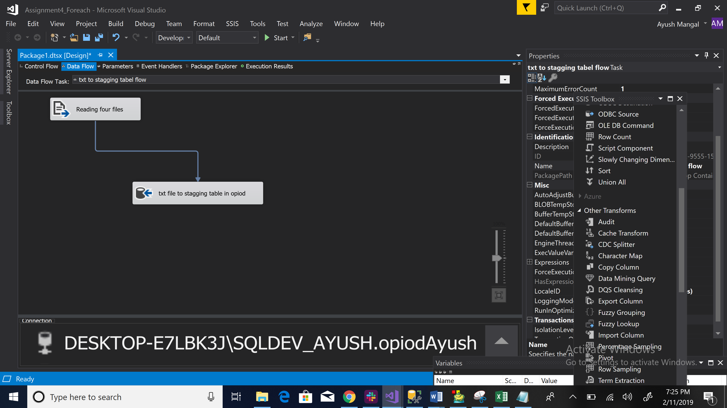

**Solution 2:**

For the purpose of 2nd solution and the further upcoming solution, we have to create the following variables in SSIS:

1. Inputfolder : Variable to get the path of the folder fom which the .txt files will be extracted.
2. Inputpath: Variable to get the path of the particular .txt file so that it can be extracted.
3. Filename: Variable to get the .txt files from the Input folder where all the .txt files have been saved.
4. Count: Variable to count the rows of a particular file in the audit table task.
5. Archievefolder: Variable to get the path of archive folder to which the .txt files will be moved after running the file system task which is named as “Archieve” in the data flow.
6. Archievefullpath: Variable to save the file inside the archive folder. We will use expression and insert a SQL statement in order to execute this step.

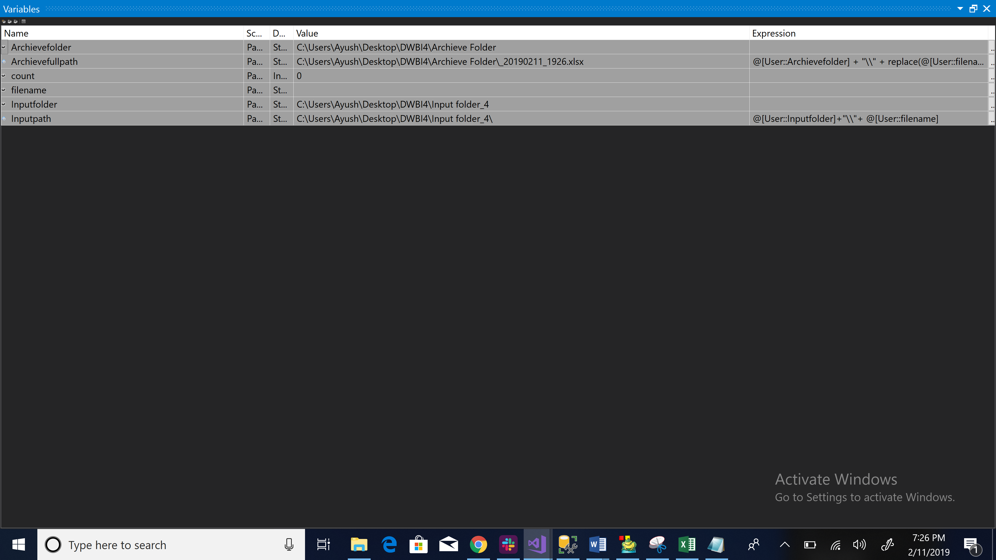

Following steps have been performed :

1. Moving the staging table to destination table.
2. With the use of derived column function, we create two columns (Year and Date_time).
3. The SSMS query result attached to show the different loading time.

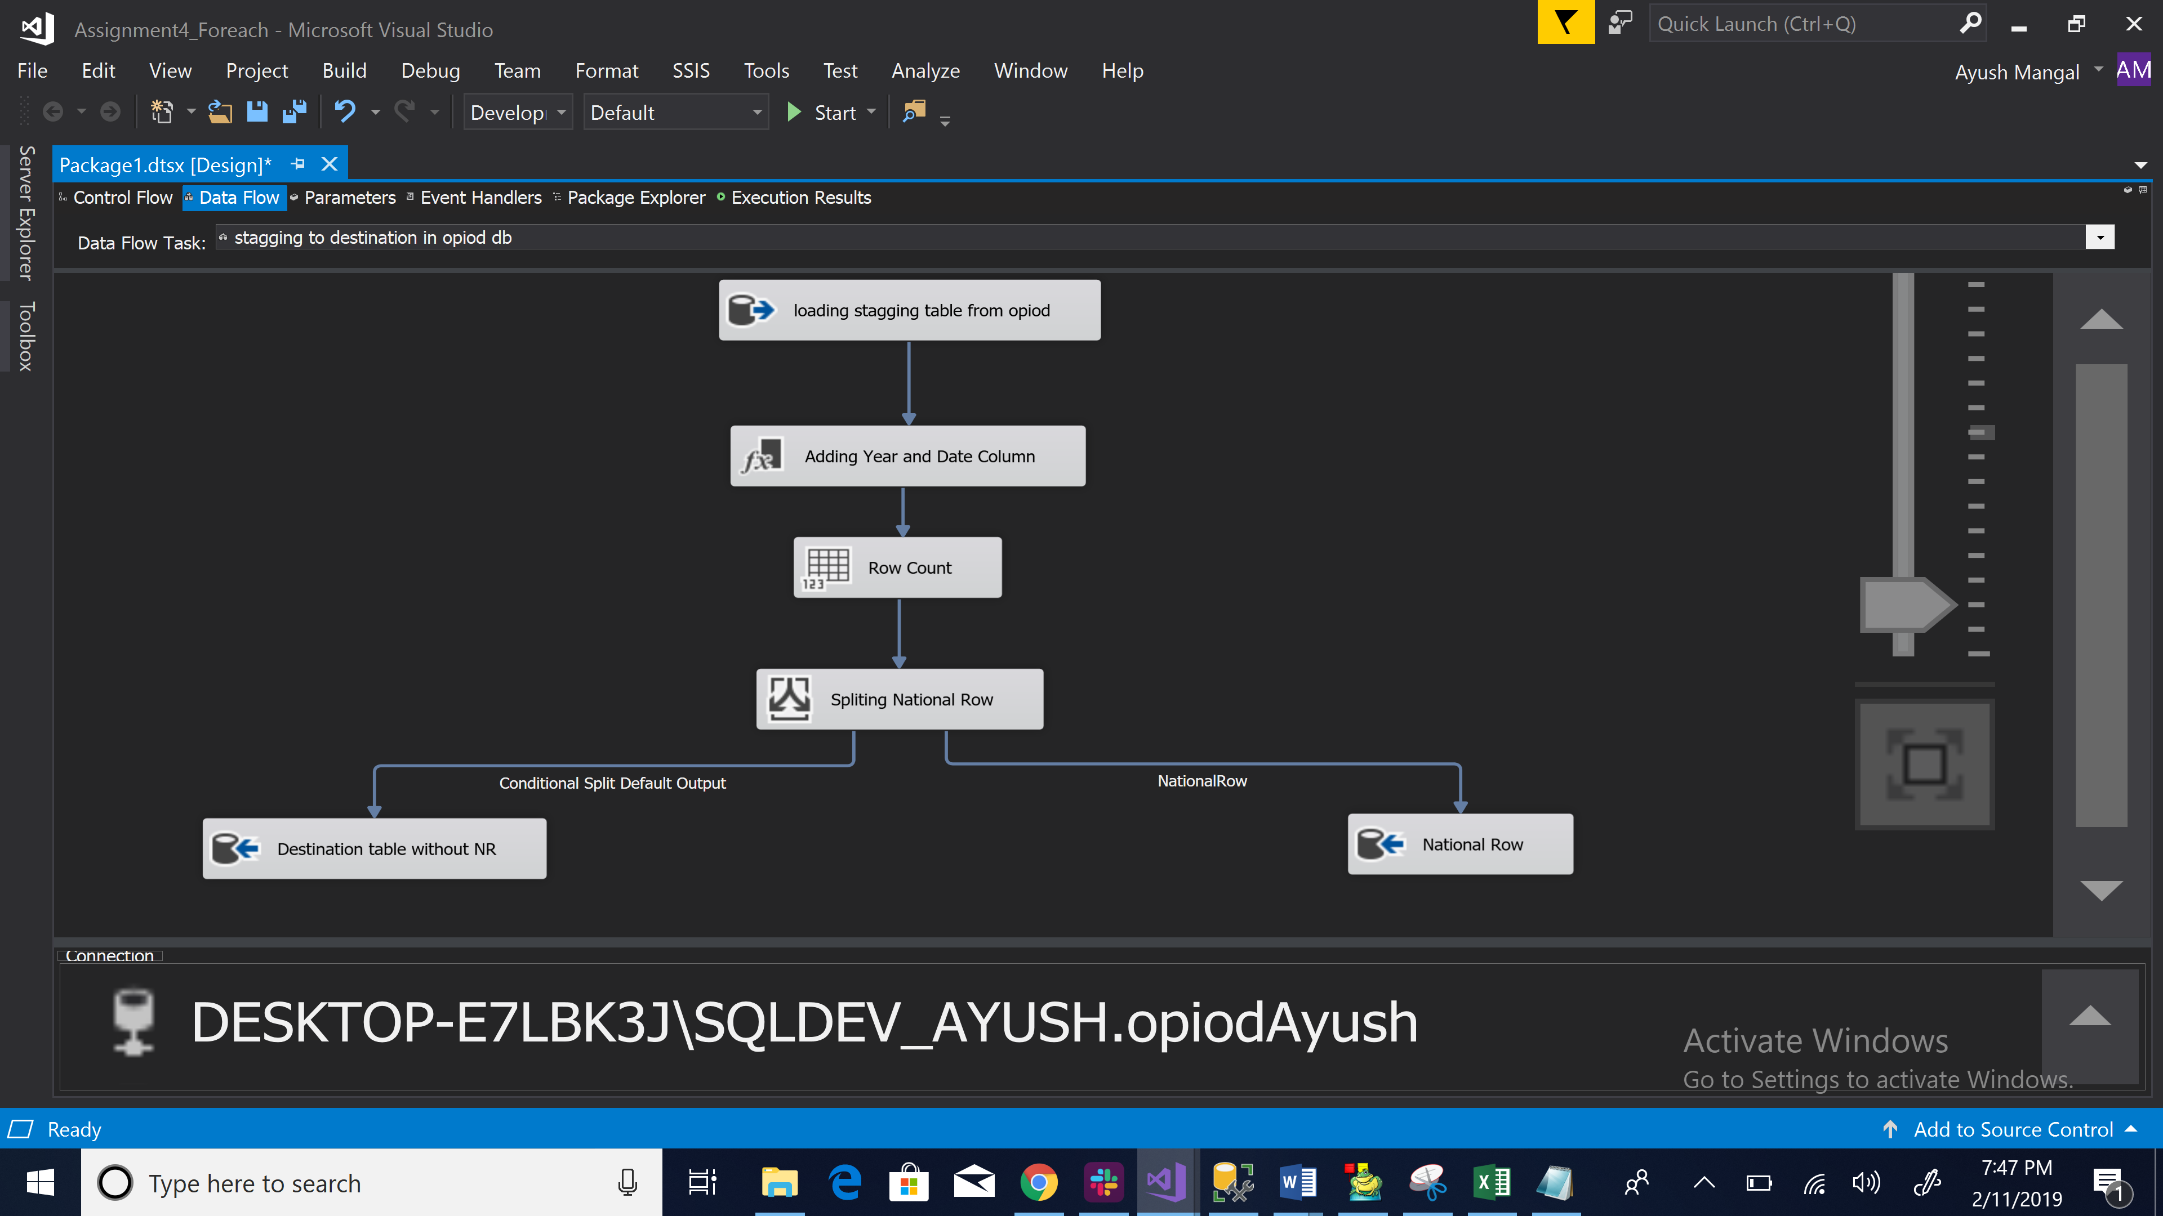

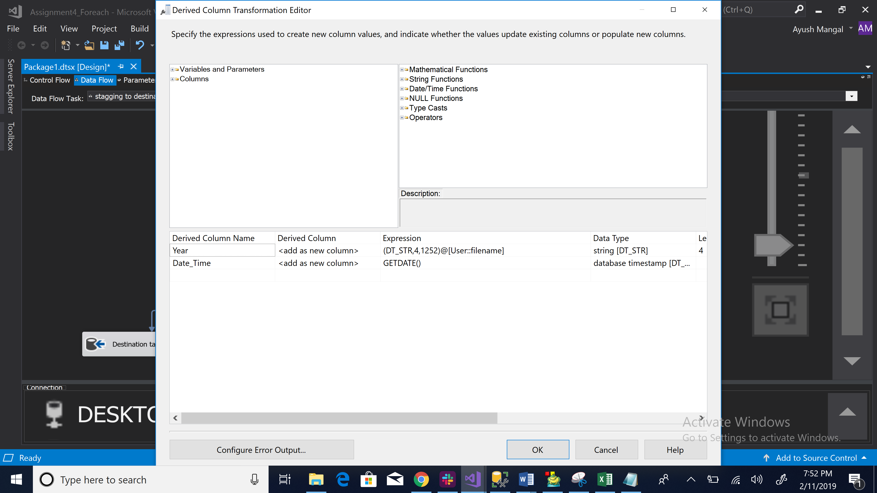

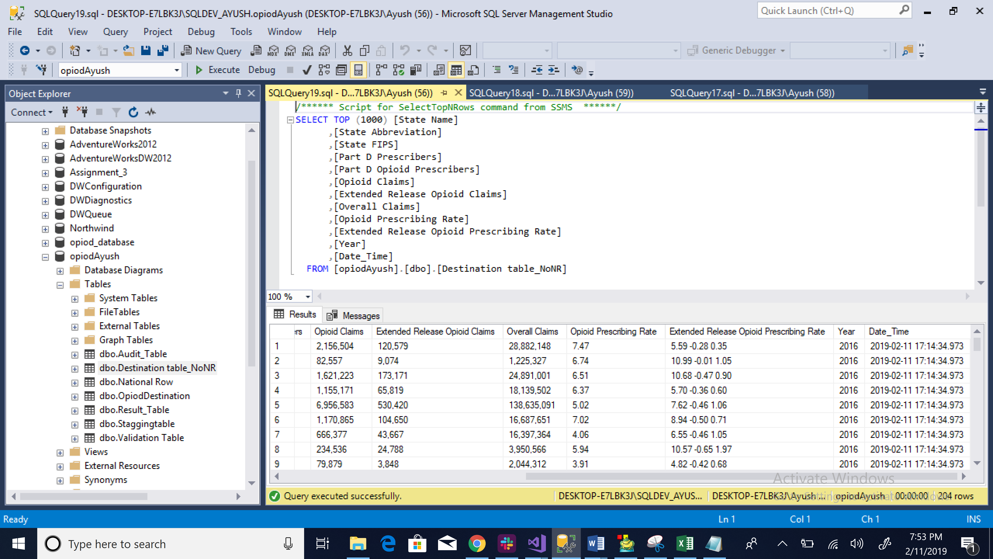

**Solution 3:** Moving the data into archive area with the additional Year and Date_Time column:

Following steps have been performed for the same:

1. We use the file system task to move the data to the archive area and named it as Archive.
2. We use the Archivefullpath variable as Destination variable.
3. We use the Inputpath variable as Source Variable.
4. After running this task, the files from the input folder will be mpved to the archive folder.

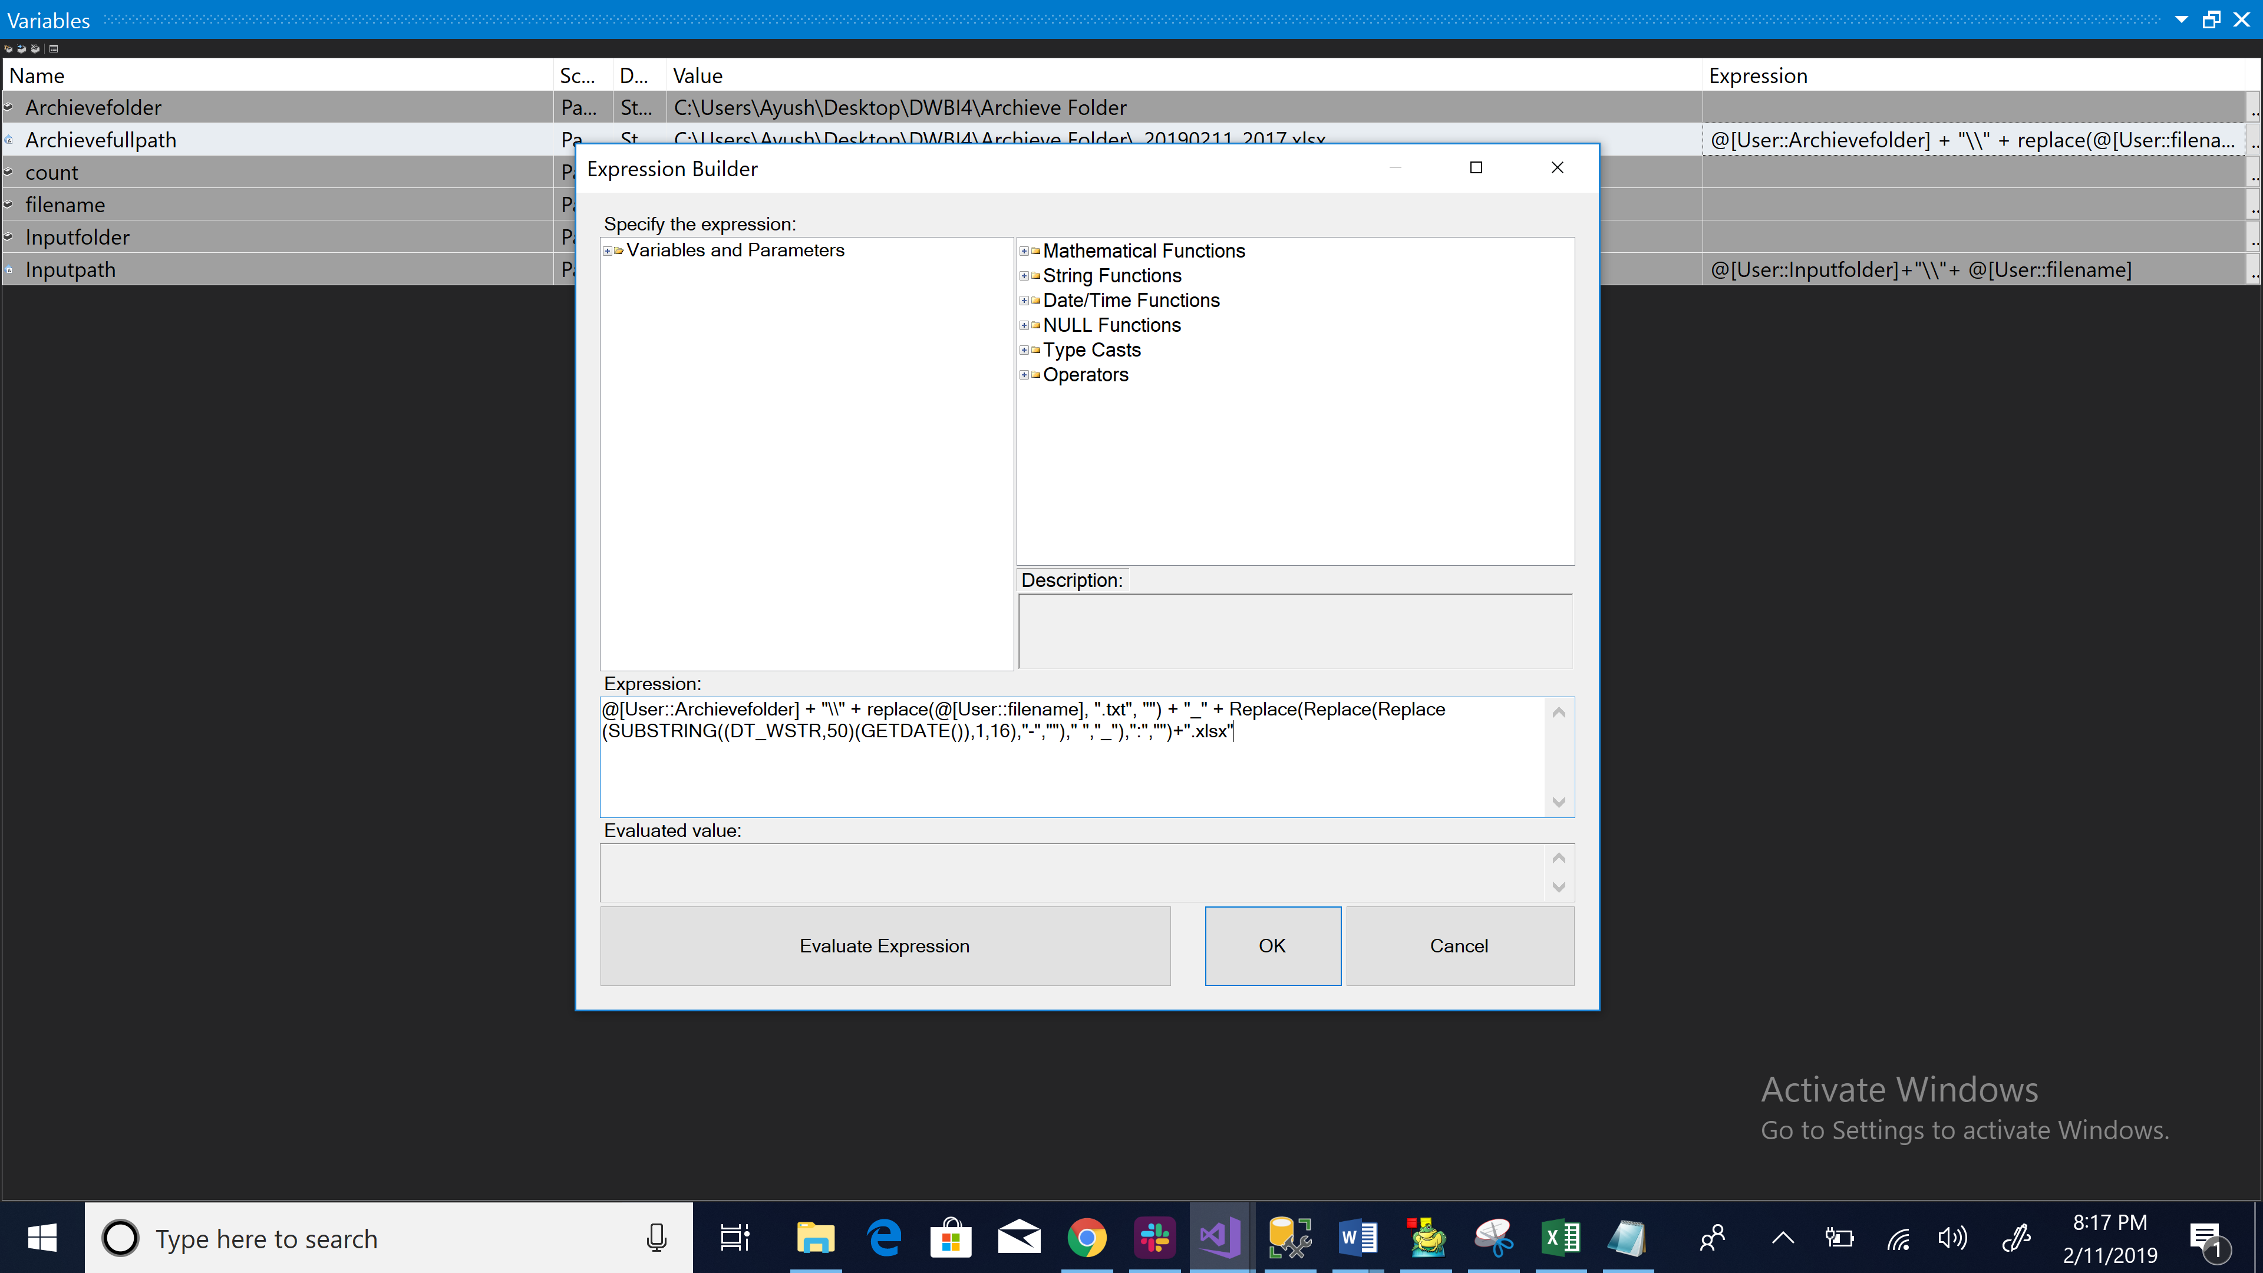

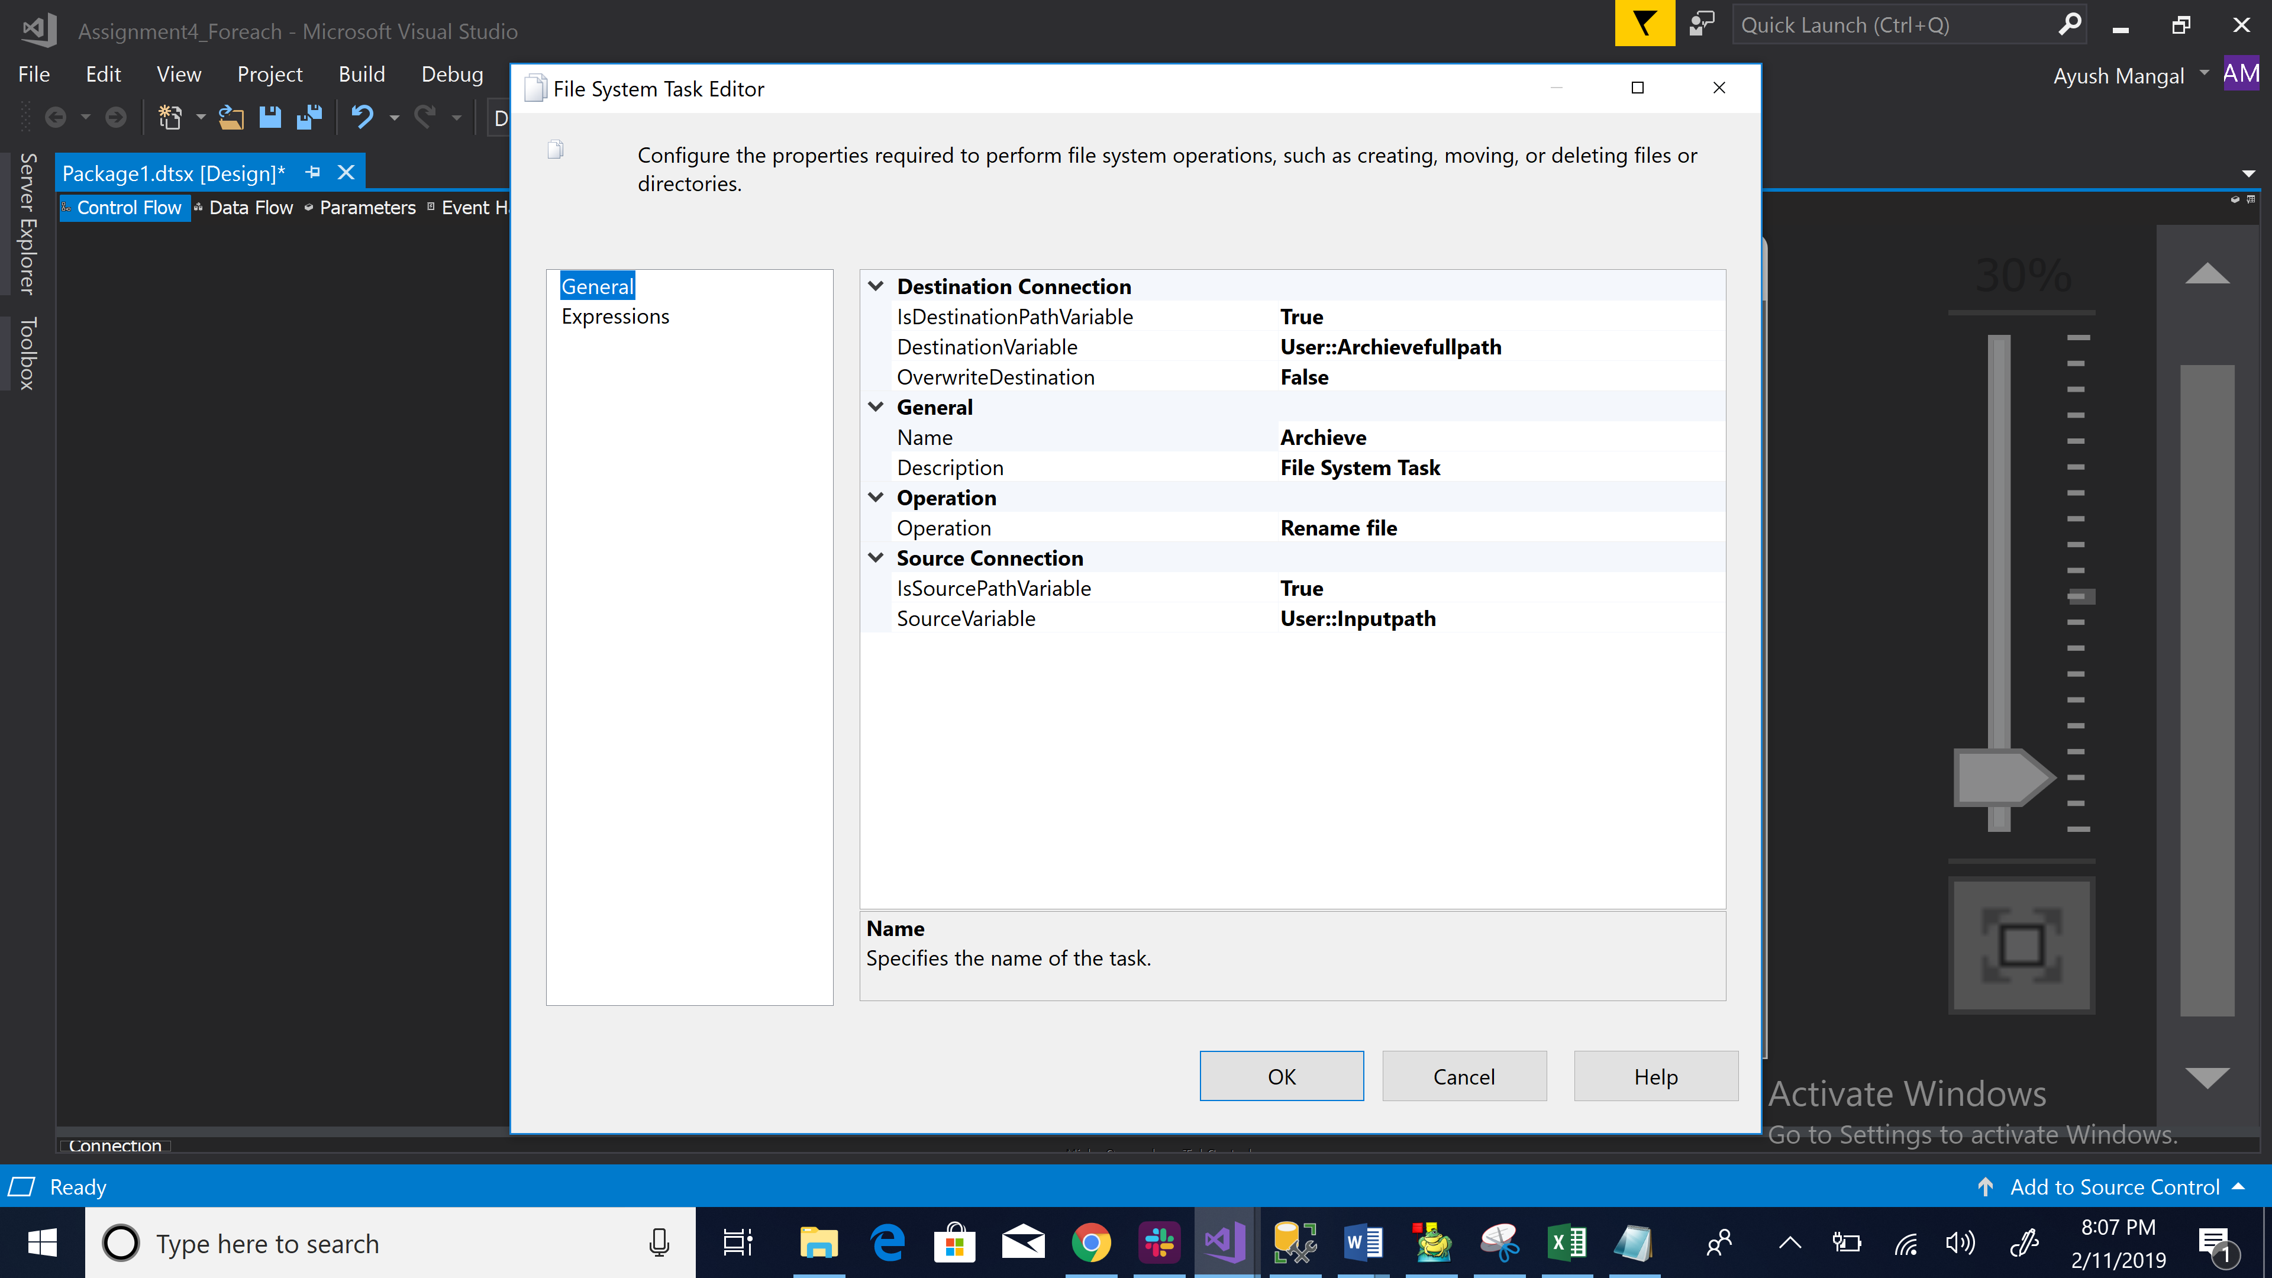

**Solution 4:**

Following steps have been performed to validate the two tables:

1. We made a validation table in SSIS which works as our flat file source.
2. Then, we used c sharp component in script component task to validate both the tables.
3. After that using the if else loop we validated that both the columns are equal and validation is successful which is shown in the destination table named as “Result_Table”.

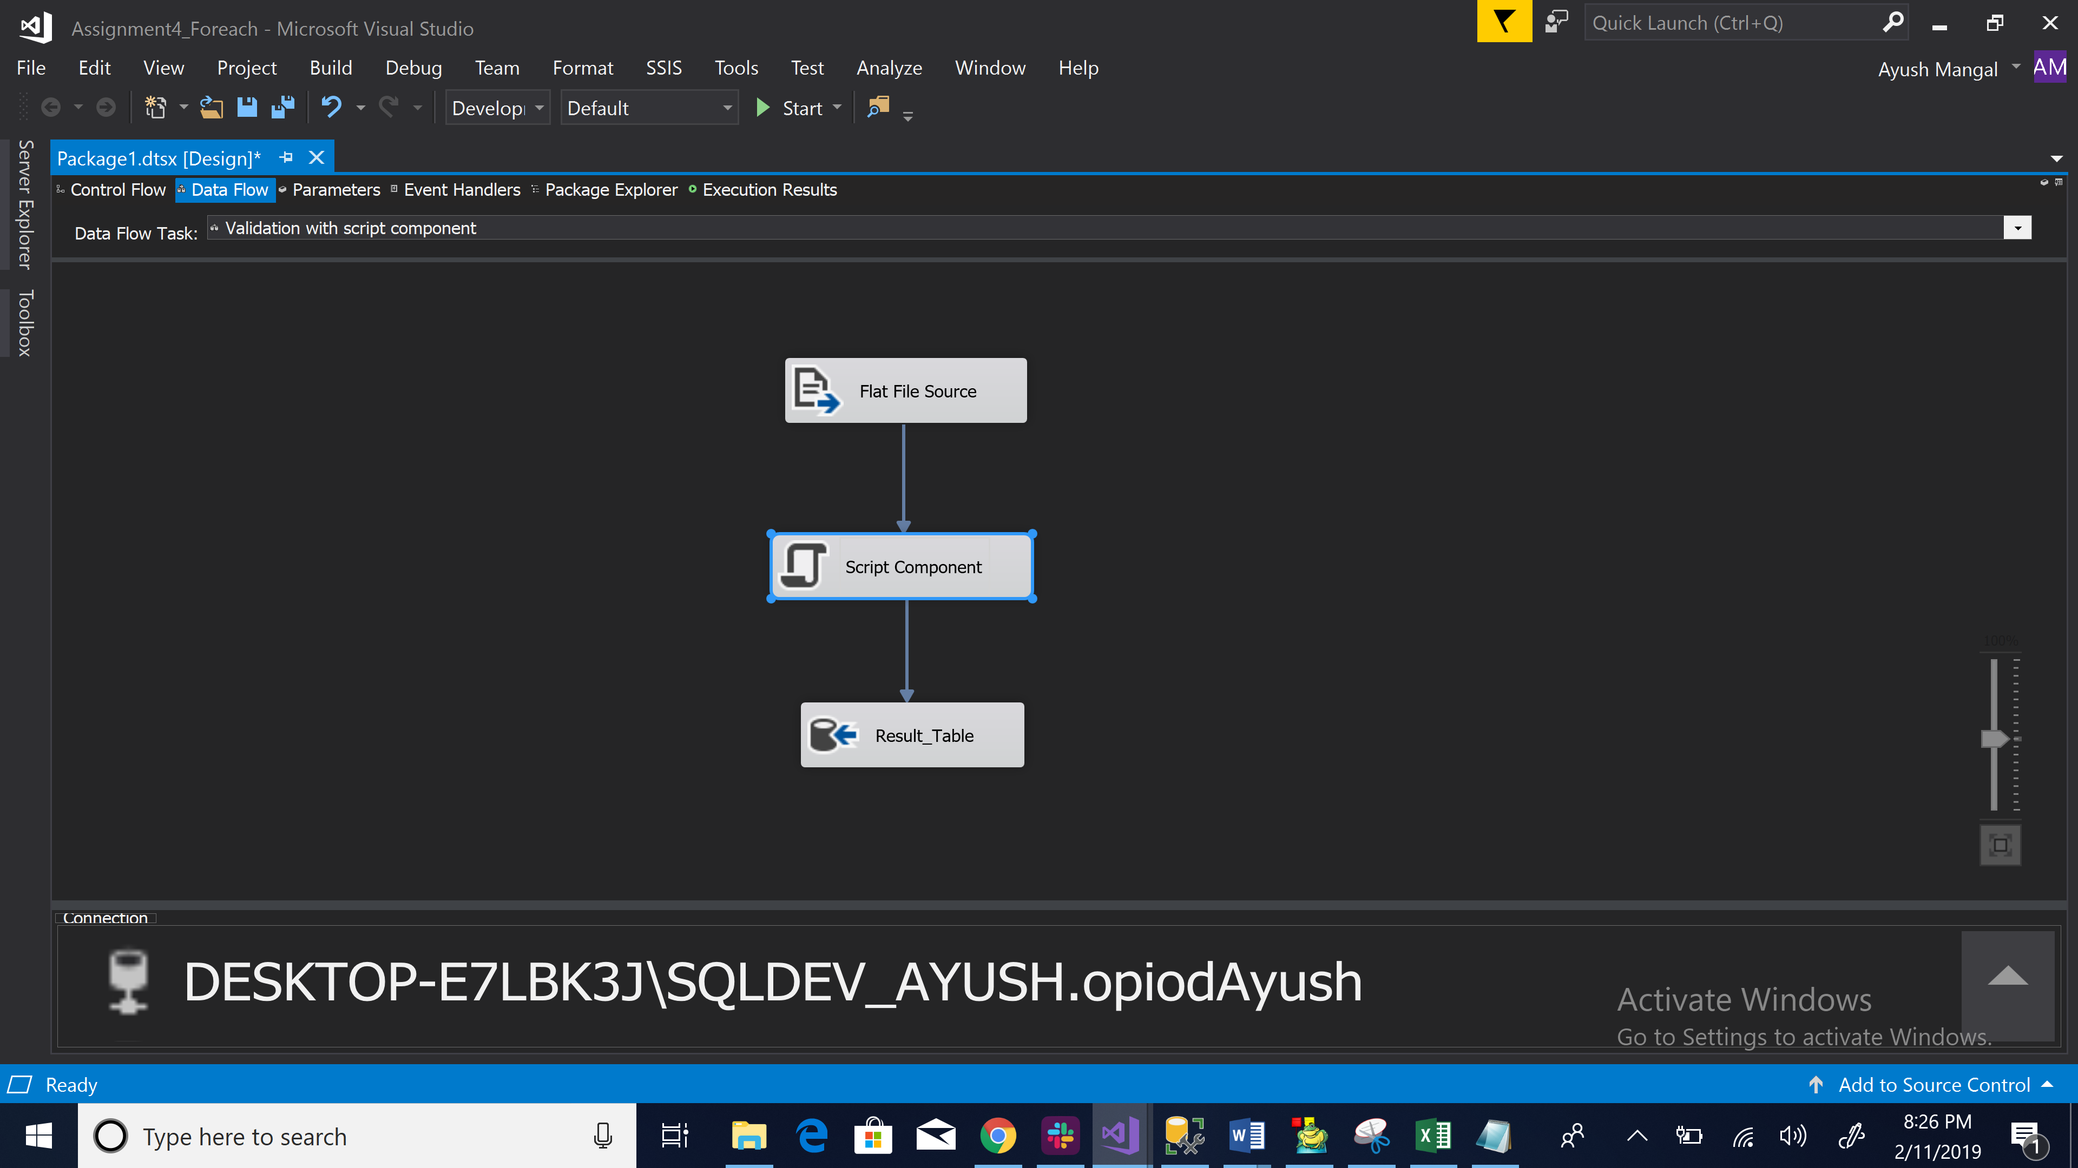

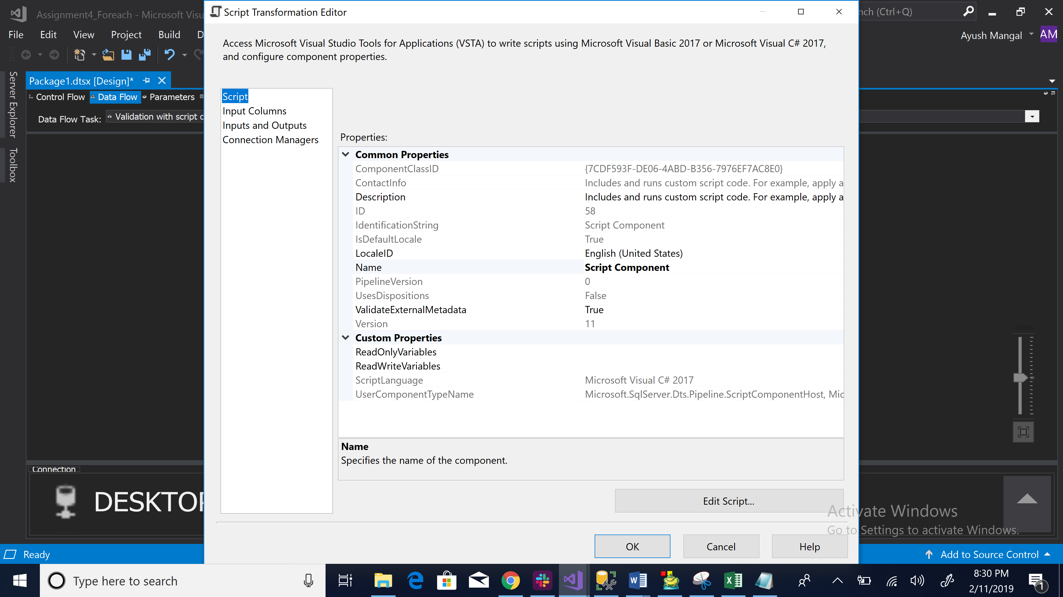

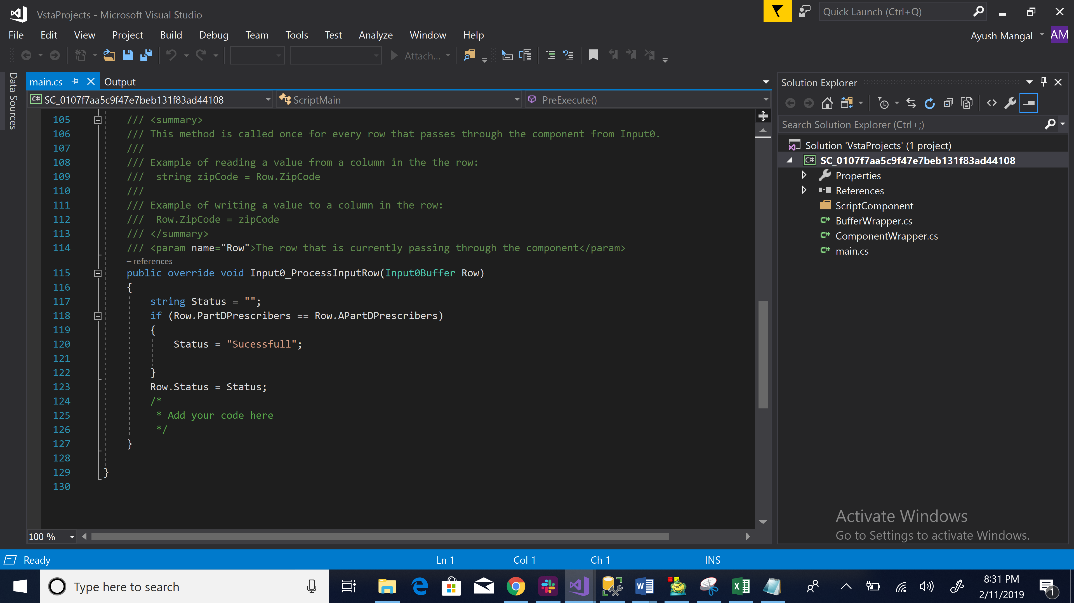

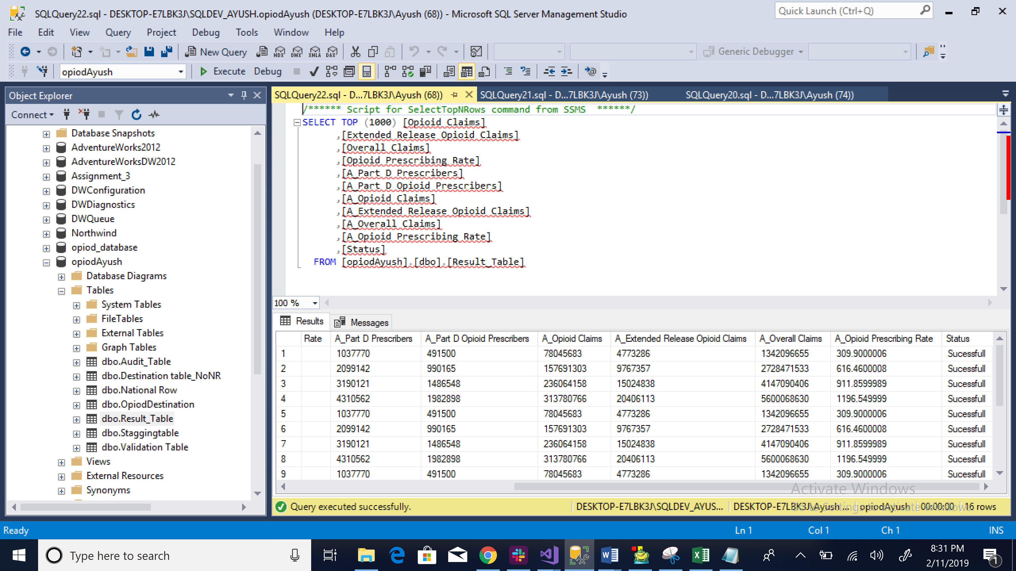

**Solution 5:** Creating an audit table that stores the results of each file loaded.

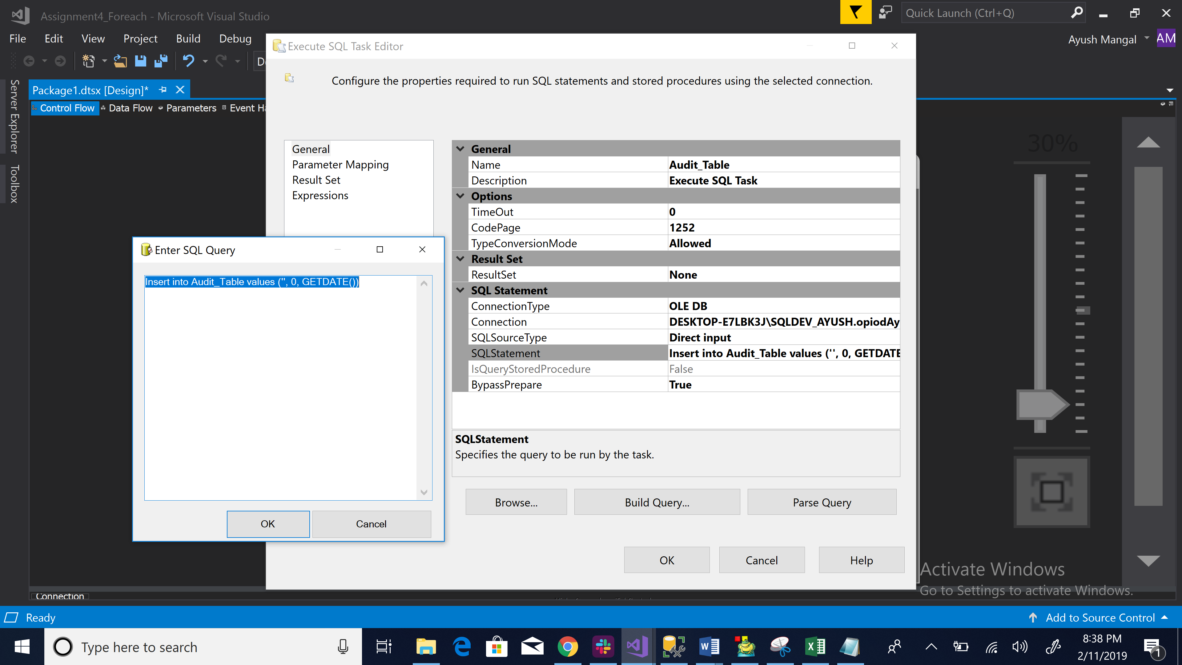

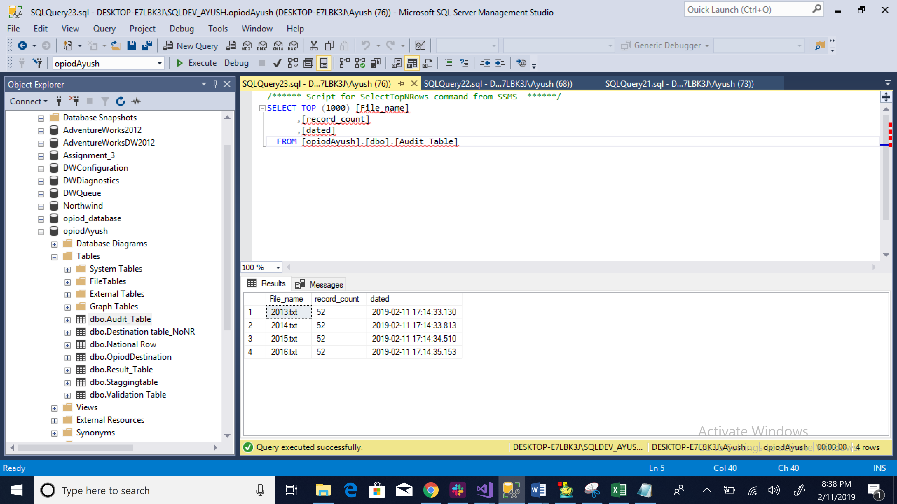

**Solution 6:** Toad Modular:

